Module Name: login page of Facebook
Test Case ID: st_01
Webpage URL: https://www.facebook.com

Scenario ID: 1a
Scenario: Sign up with valid credentials
Test Steps:
- Click on create new account
- Enter Email
- Enter Full Name
- Enter Username
- Enter Password
- Click on Sign Up

Screenshots: 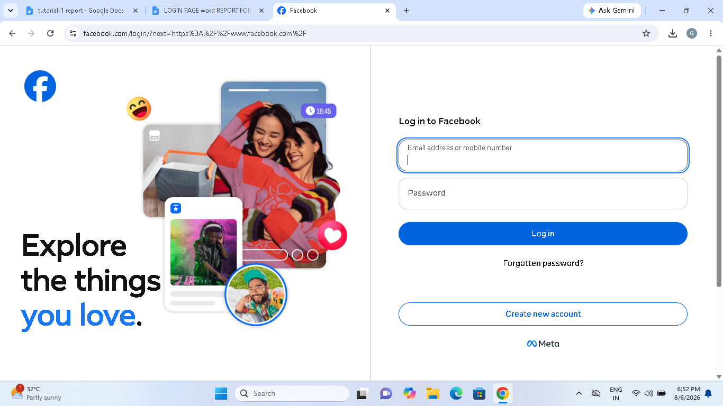

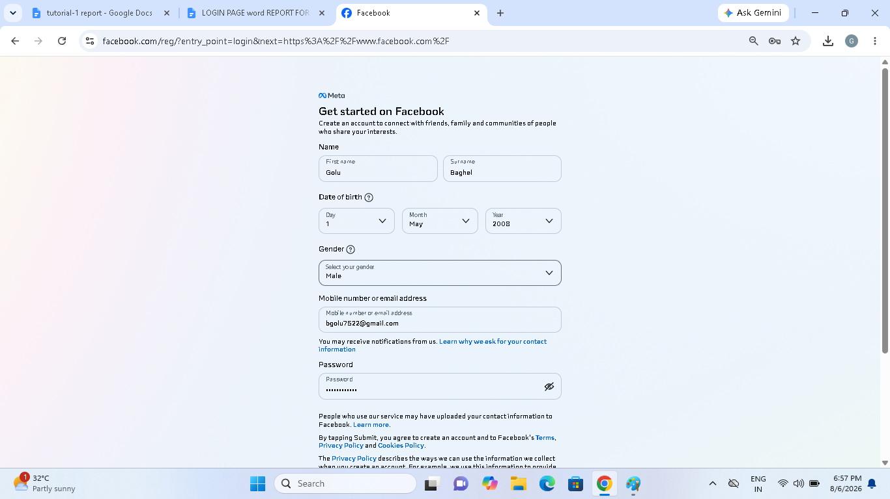
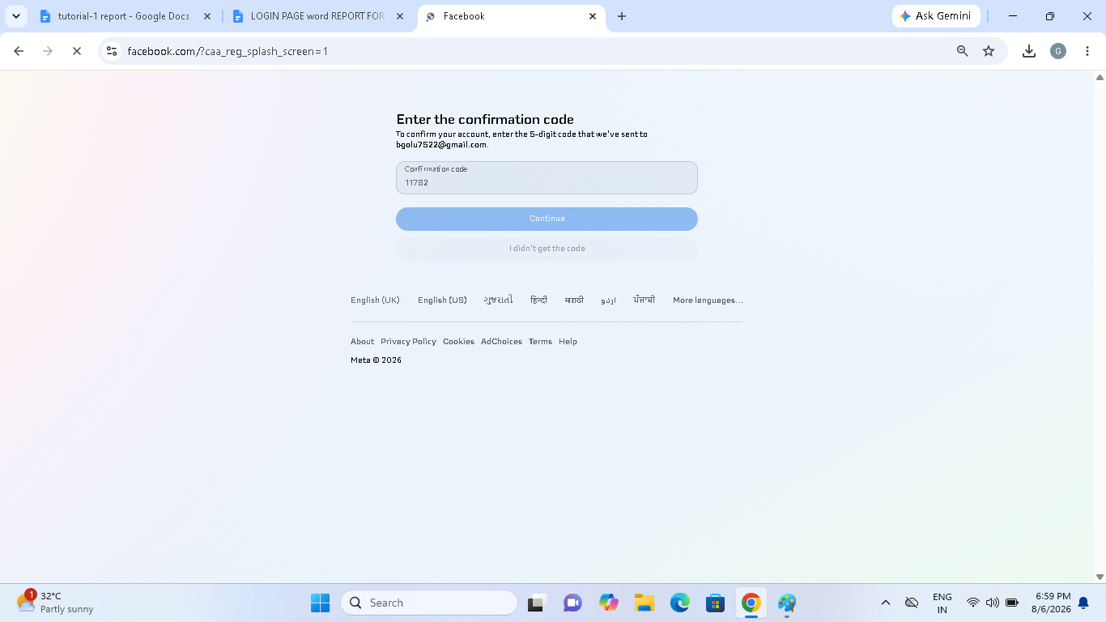

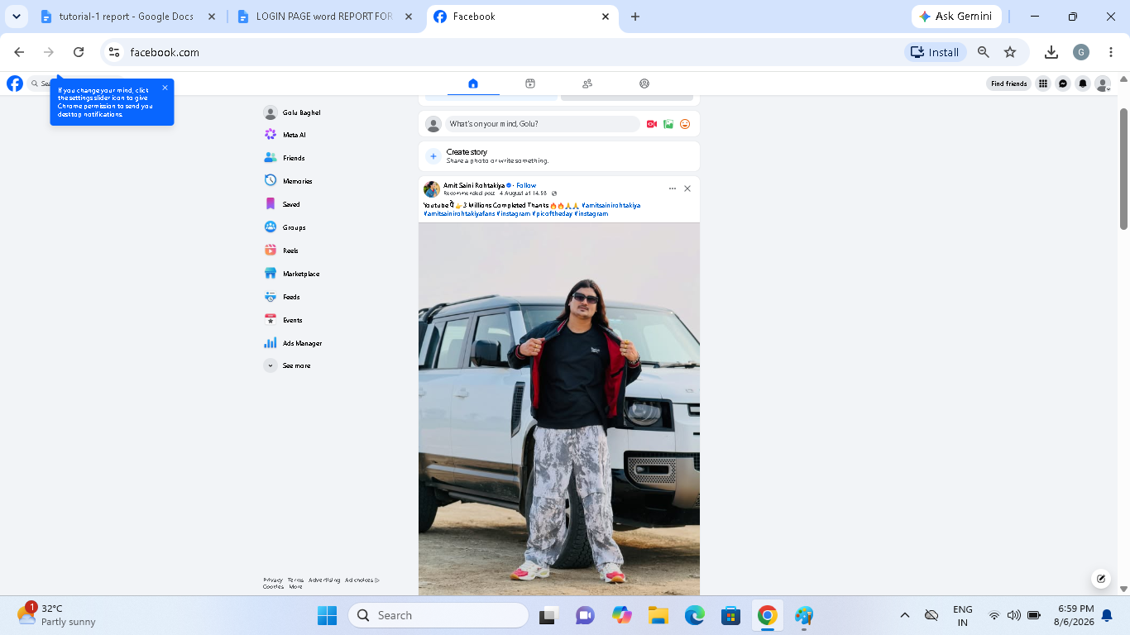

Scenario ID: 1b
Scenario: Log-in using already registered email
Test Steps:
- Click on continue
- Enter existing Email
- Fill all fields
- Click on Sign Up
Screenshots:

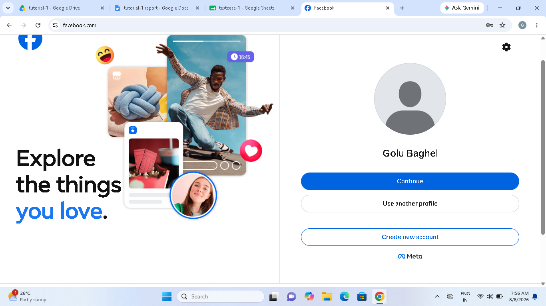

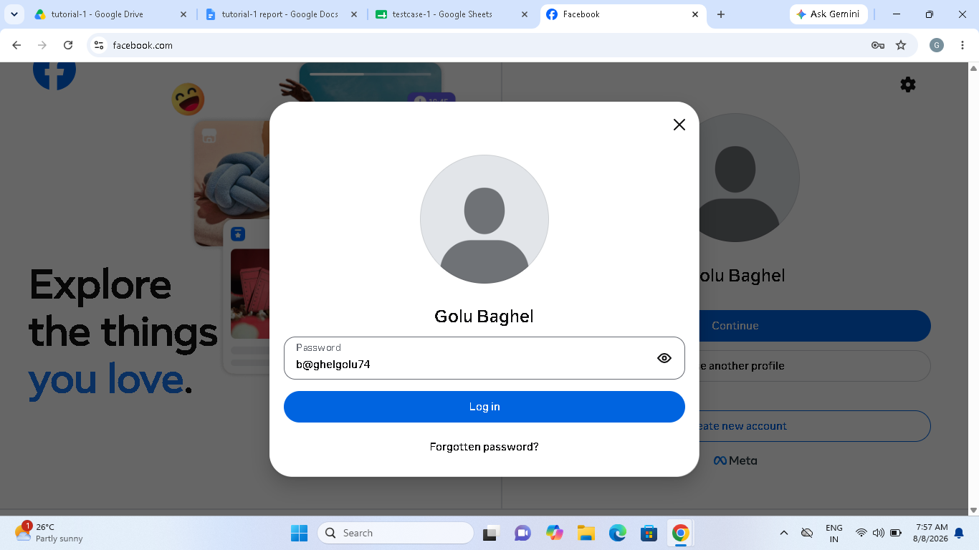
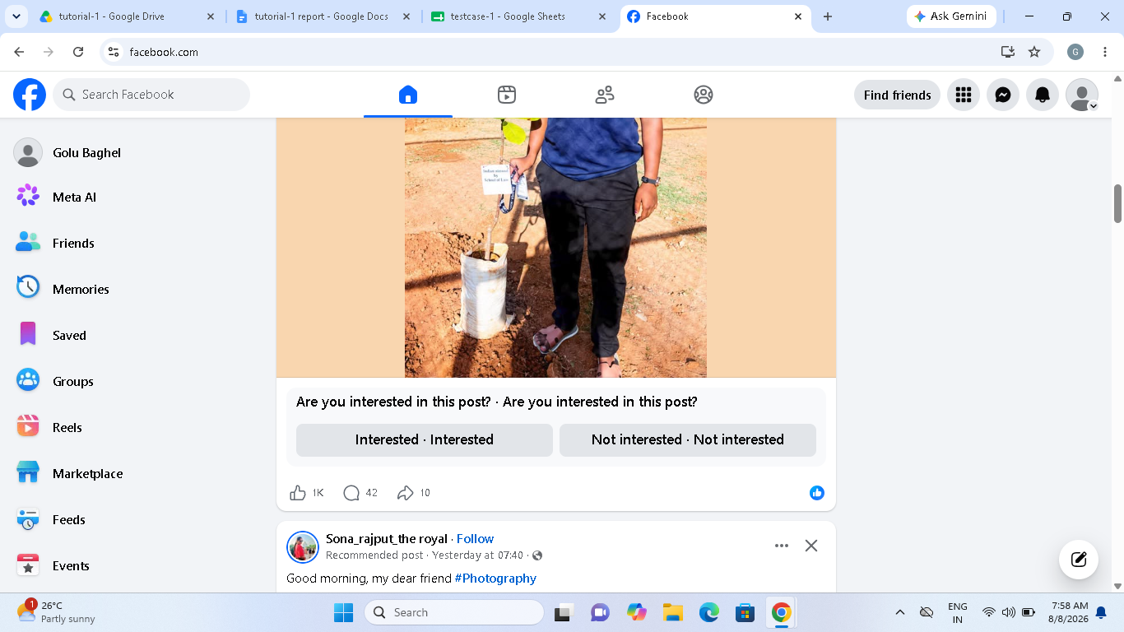

Scenario ID: 1c
Scenario: Log-in with invalid username
Test Steps:
- Click on create new account
- Enter Username with special characters or spaces
- Fill other fields
- Click on submit
Screenshots:

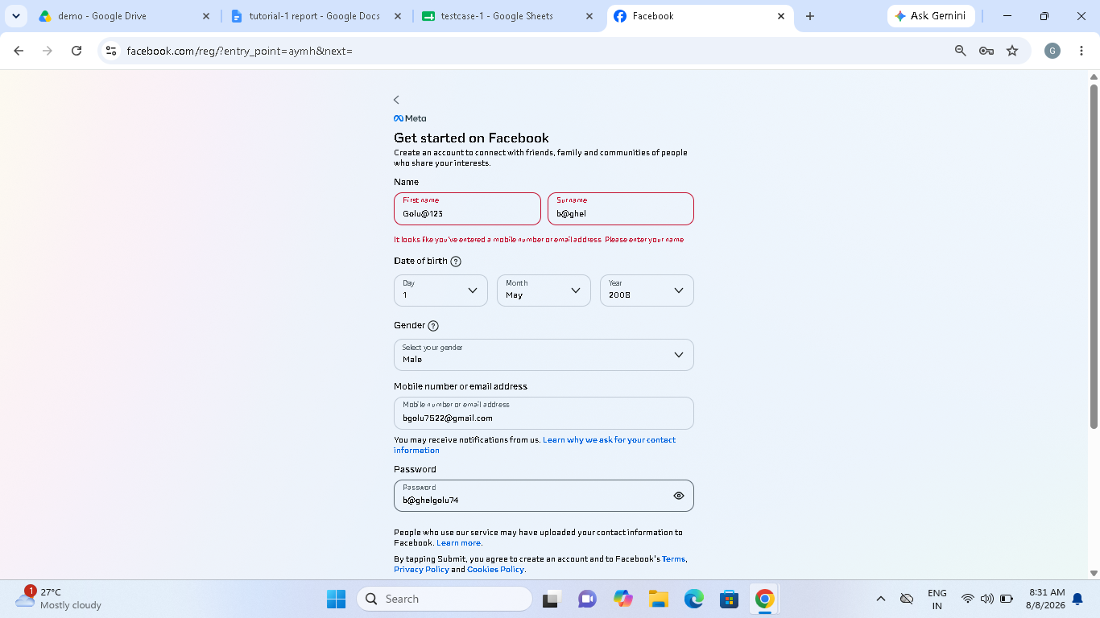

Scenario ID: 1d
Scenario: Sign up with only whitespace inputs
Test Steps:
- Click on Sign Up
- Enter space characters in required fields
- Click on Sign Up
Screenshots:

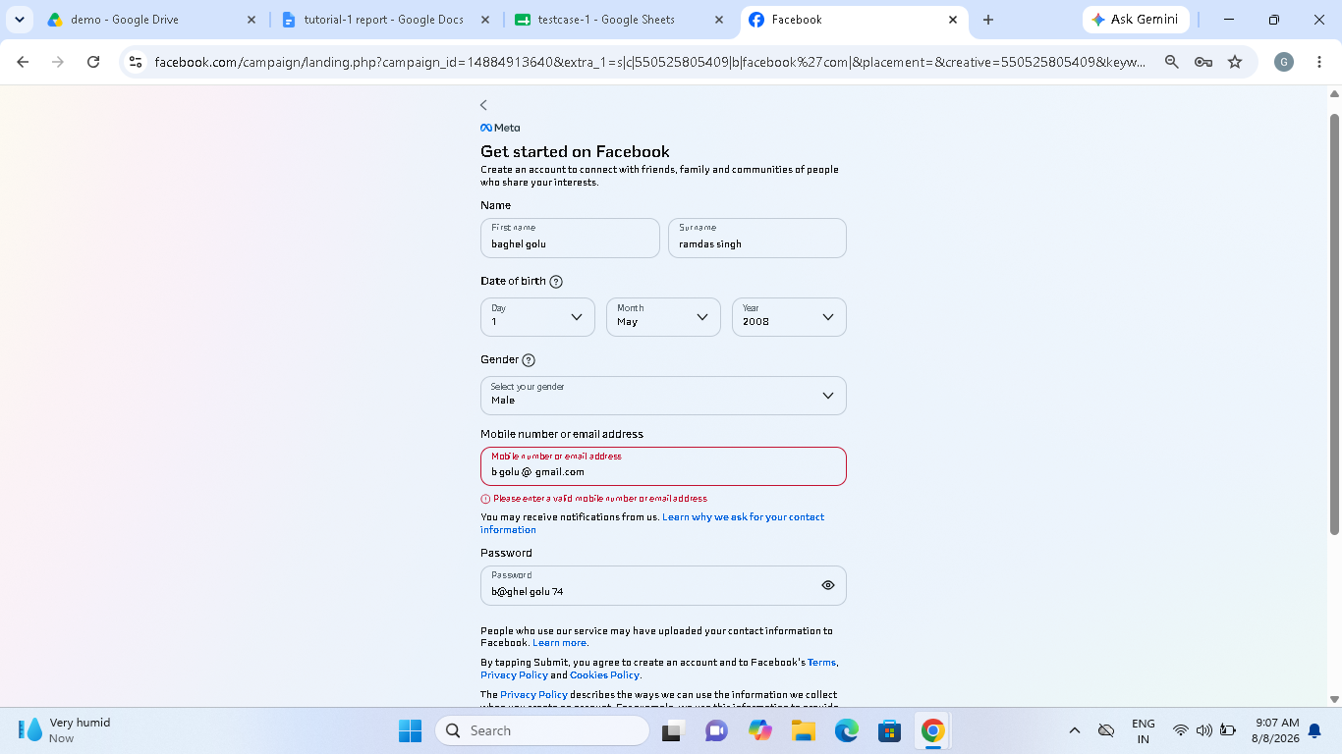

Scenario ID: 1e
Scenario: Sign up with weak password
Test Steps:
- Click on Sign Up
- Enter valid Email, Name, and Username
- Enter weak Password
- Click on Sign Up
Screenshots:

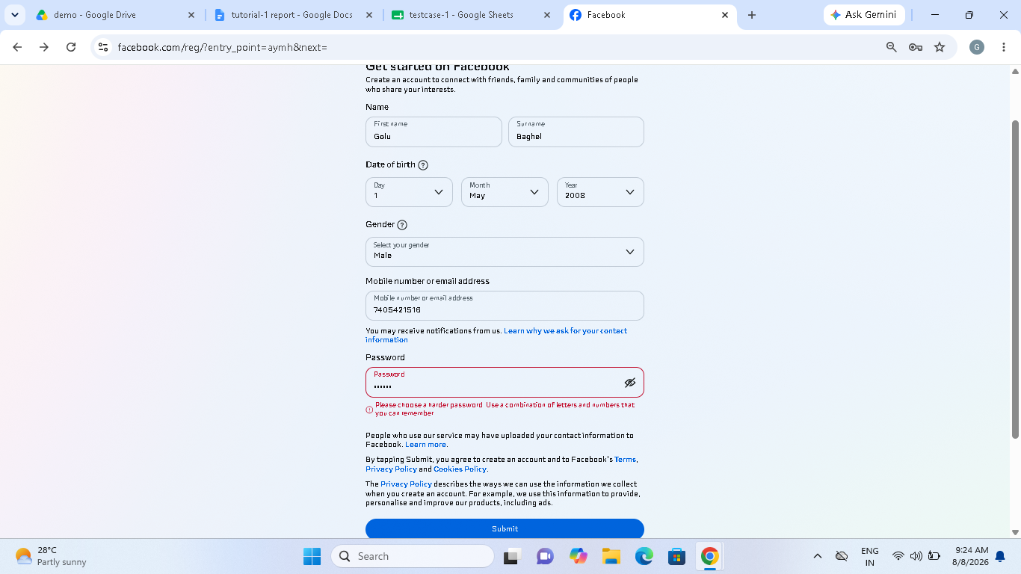

Scenario ID: 1f
Scenario: Check password visibility toggle
Test Steps:
- Click on Sign Up
- Enter Password
- Click on eye icon beside password field
Screenshots:
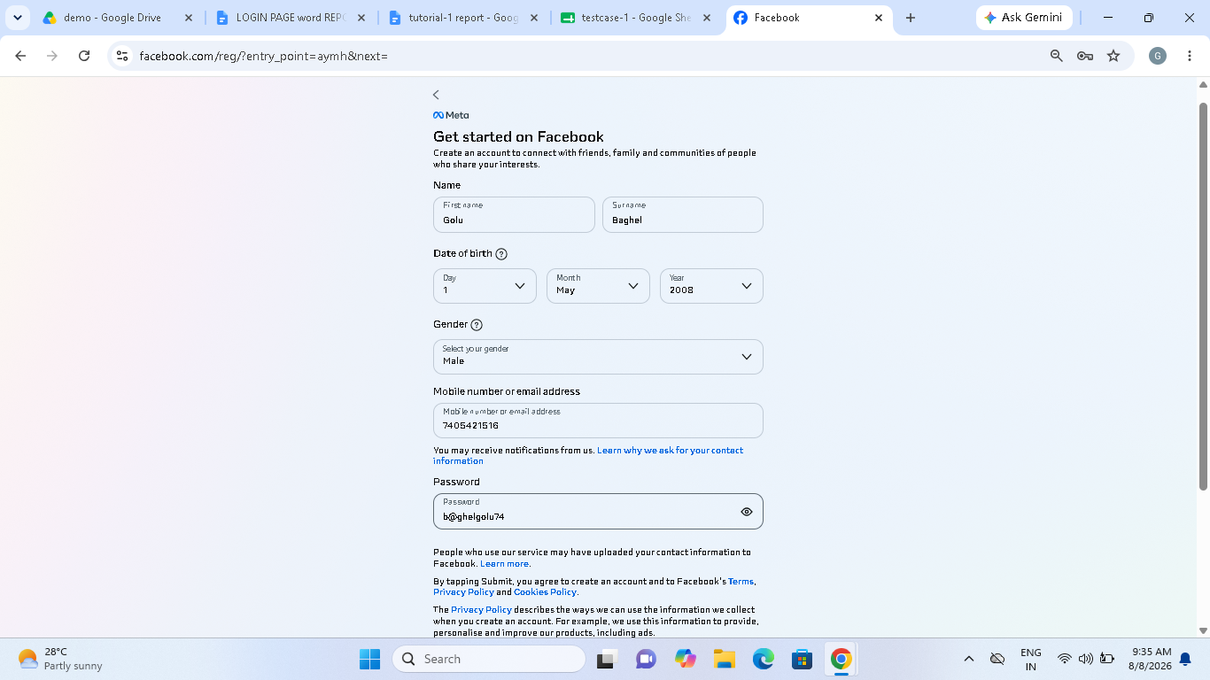

Scenario ID: 1g
Scenario: Sign up with international phone number
Test Steps:
- Click on Sign Up
- Enter phone number with country code
- Fill other fields
- Click on Sign Up
Screenshots:
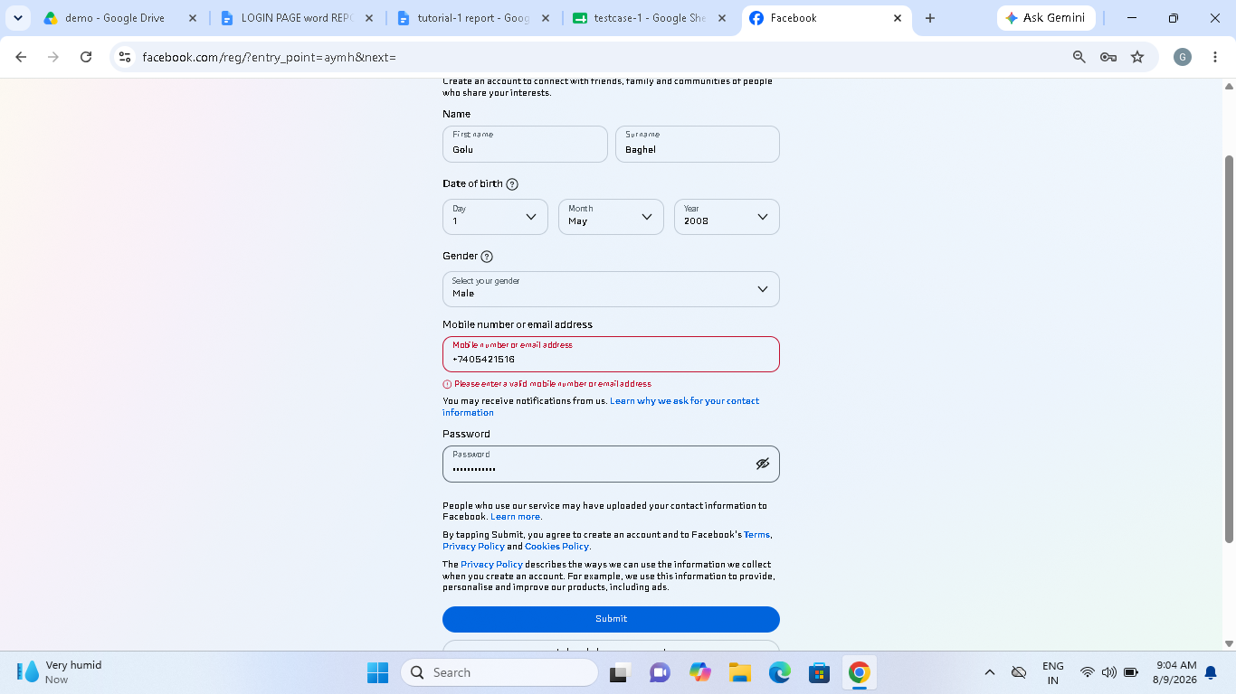

Scenario ID: 2a
Scenario: Login with valid credentials
Test Steps:
- Click on Log In
- Enter valid Username and Password
- Click Log In
Screenshots:

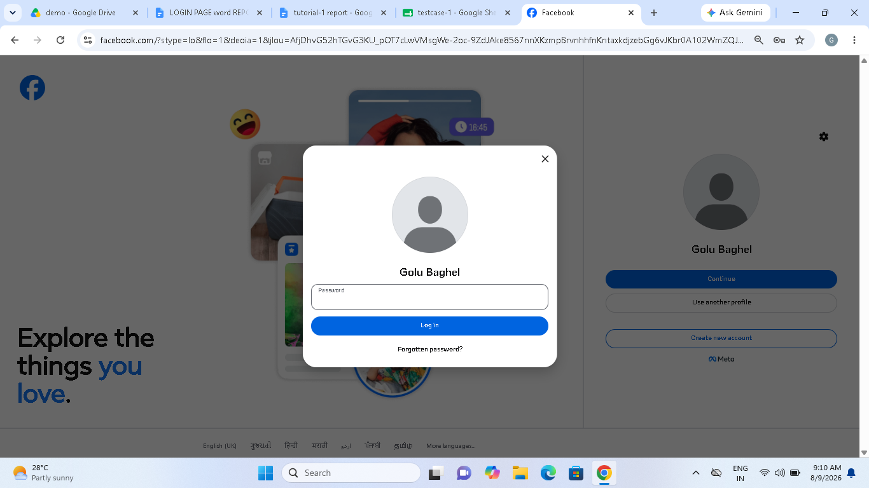

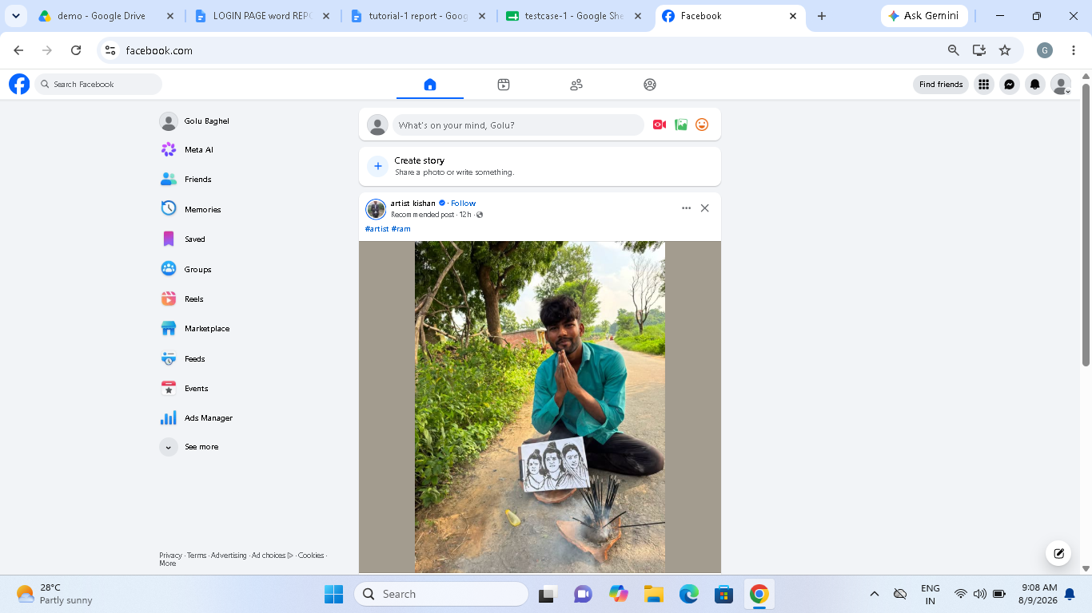

Scenario ID: 2b
Scenario: Login with wrong password
Test Steps:
- Click on Log In
- Enter valid username and wrong password
- Click Log In
Screenshots:

